Create a Spring Web Project using Maven
Pom.xml:
<?xml version="1.0" encoding="UTF-8"?>
<project xmlns="https://maven.apache.org/POM/4.0.0" xmlns:xsi="http://www.w3.org/2001/XMLSchema-instance"
xsi:schemaLocation="http://maven.apache.org/POM/4.0.0 https://maven.apache.org/xsd/maven-4.0.0.xsd">
<modelVersion>4.0.0</modelVersion>
<parent>
<groupId>org.springframework.boot</groupId>
<artifactId>spring-boot-starter-parent</artifactId>
<version>4.1.0</version>
<relativePath/> <!-- lookup parent from repository -->
</parent>
<groupId>com.cognizant</groupId>
<artifactId>spring-learn</artifactId>
<version>0.0.1-SNAPSHOT</version>
<name/>
<description/>
<url/>
<licenses>
<license/>
</licenses>
<developers>
<developer/>
</developers>
<scm>
<connection/>
<developerConnection/>
<tag/>
<url/>
</scm>
<properties>
<java.version>21</java.version>
</properties>
<dependencies>

<dependency>
<groupId>org.springframework.boot</groupId>
<artifactId>spring-boot-starter-webmvc</artifactId>
</dependency>

<dependency>
<groupId>org.springframework.boot</groupId>
<artifactId>spring-boot-devtools</artifactId>
<scope>runtime</scope>
<optional>true</optional>
</dependency>
<dependency>
<groupId>org.springframework.boot</groupId>
<artifactId>spring-boot-starter-data-jpa-test</artifactId>
<scope>test</scope>
</dependency>
<dependency>
<groupId>org.springframework.boot</groupId>
<artifactId>spring-boot-starter-webmvc-test</artifactId>
<scope>test</scope>
</dependency>
</dependencies>

<build>
<plugins>
<plugin>
<groupId>org.springframework.boot</groupId>
<artifactId>spring-boot-maven-plugin</artifactId>
</plugin>
</plugins>
</build>

</project>

Output:
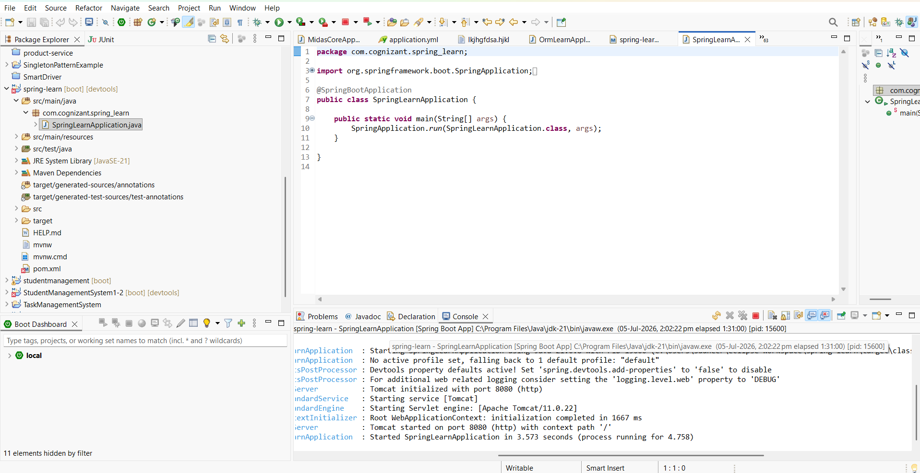

Spring Core – Load Country from Spring Configuration XML
Spring-learnapplication.java
package com.cognizant.spring_learn;

import java.text.SimpleDateFormat;
import java.util.Date;

import org.springframework.boot.SpringApplication;
import org.springframework.boot.autoconfigure.SpringBootApplication;
import org.springframework.context.ApplicationContext;
import org.springframework.context.support.ClassPathXmlApplicationContext;

@SpringBootApplication
public class SpringLearnApplication {

public static void main(String[] args) throws Exception {

SpringApplication.run(SpringLearnApplication.class, args);

displayDate();
}

public static void displayDate() throws Exception {

ApplicationContext context =
new ClassPathXmlApplicationContext("date-format.xml");

SimpleDateFormat format =
context.getBean("dateFormat", SimpleDateFormat.class);

Date date = format.parse("31/12/2018");

System.out.println(date);
}

}
Output:
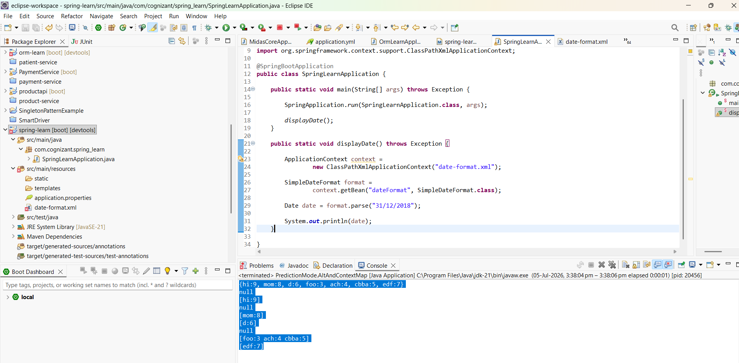

Hello World RESTful Web Service
Output:

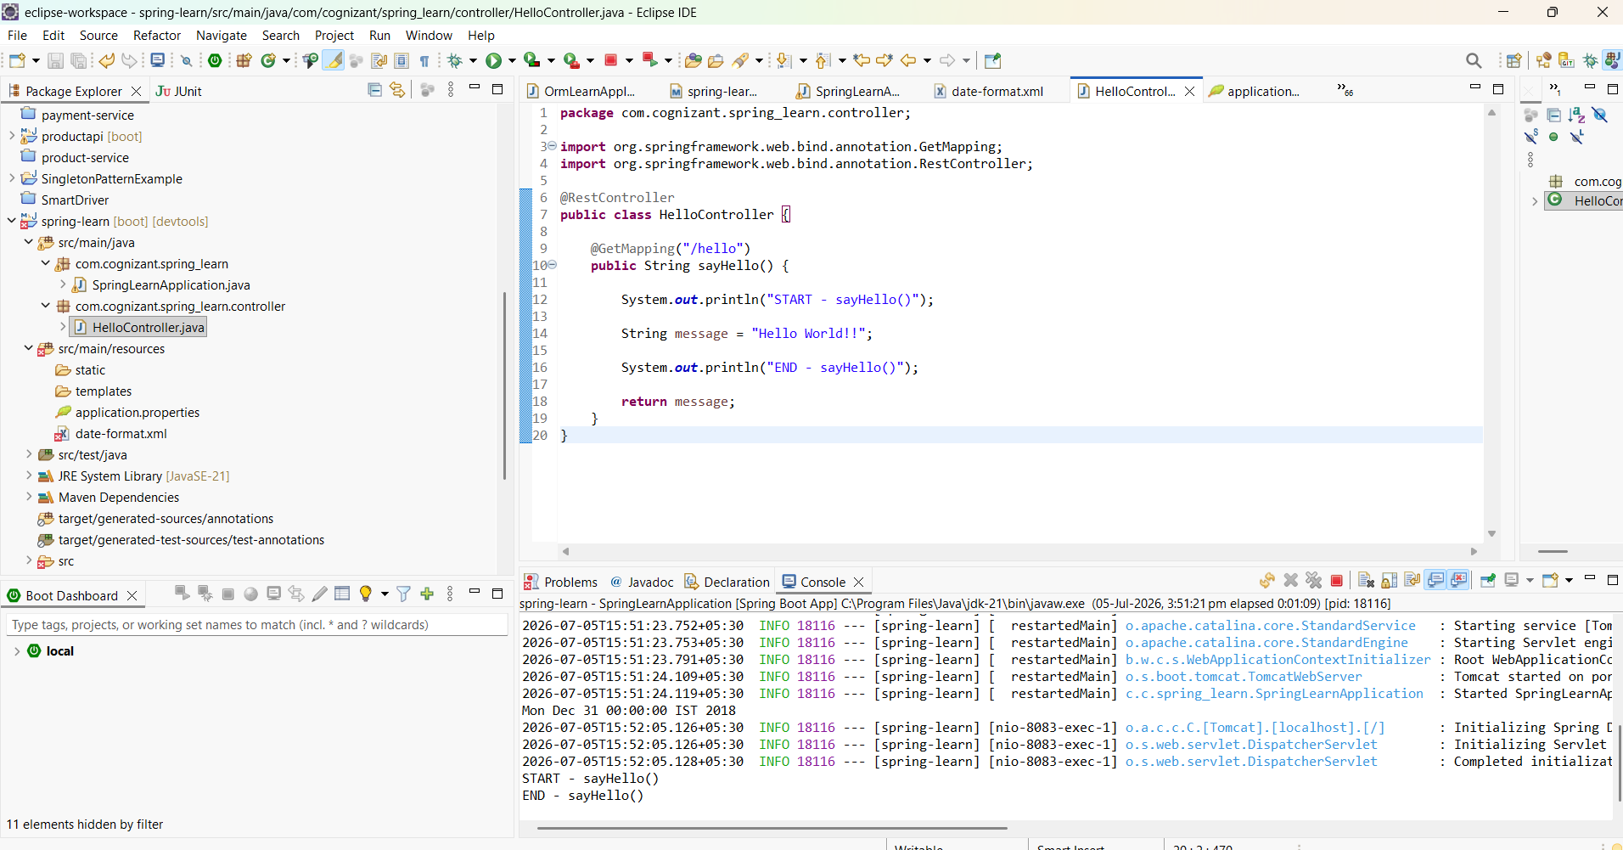
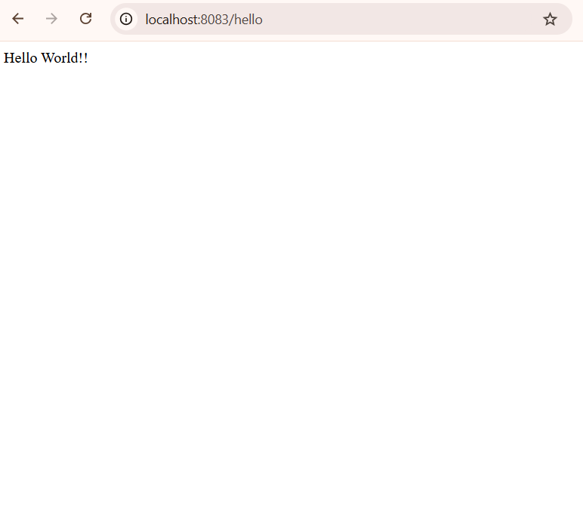
REST - Country Web Service
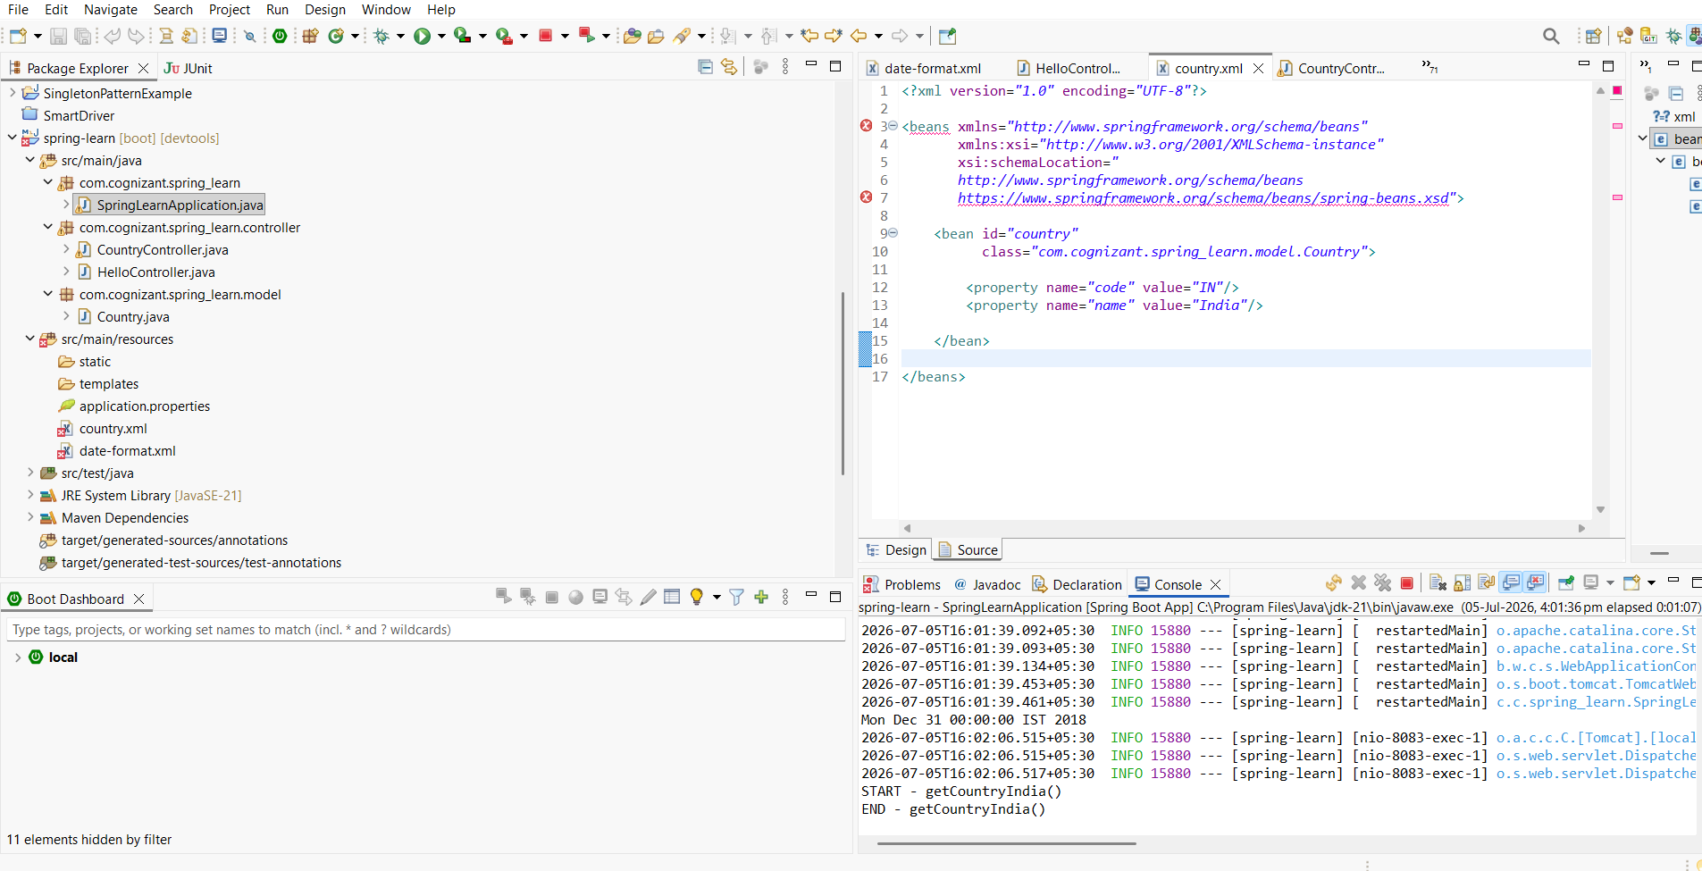

CountryController
package com.cognizant.spring_learn.controller;

import org.springframework.context.ApplicationContext;
import org.springframework.context.support.ClassPathXmlApplicationContext;
import org.springframework.web.bind.annotation.RequestMapping;
import org.springframework.web.bind.annotation.RestController;

import com.cognizant.spring_learn.model.Country;

@RestController
public class CountryController {

@RequestMapping("/country")
public Country getCountryIndia() {

System.out.println("START - getCountryIndia()");

ApplicationContext context =
new ClassPathXmlApplicationContext("country.xml");

Country country = context.getBean("country", Country.class);

System.out.println("END - getCountryIndia()");

return country;
}
}
HelloController
package com.cognizant.spring_learn.controller;

import org.springframework.web.bind.annotation.GetMapping;
import org.springframework.web.bind.annotation.RestController;

@RestController
public class HelloController {

@GetMapping("/hello")
public String sayHello() {

System.out.println("START - sayHello()");

String message = "Hello World!!";

System.out.println("END - sayHello()");

return message;
}
}
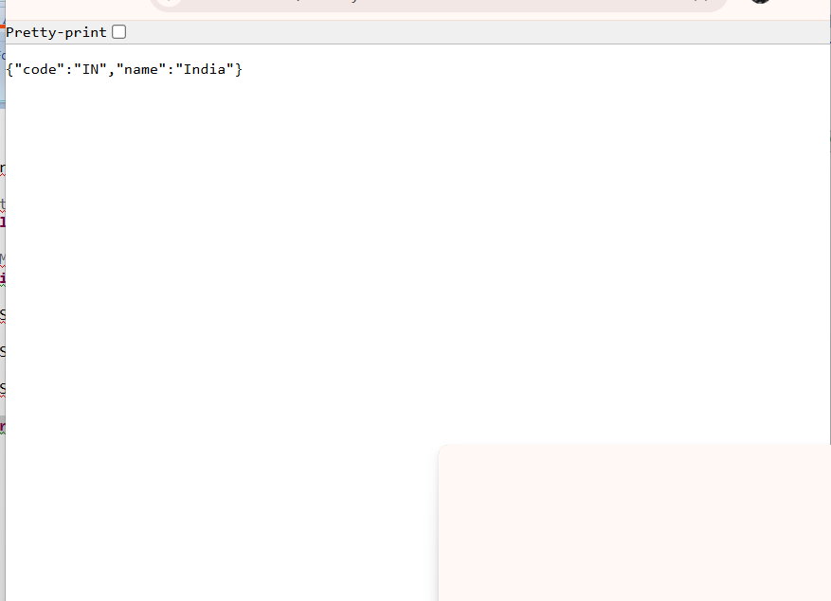
REST - Get country based on country code
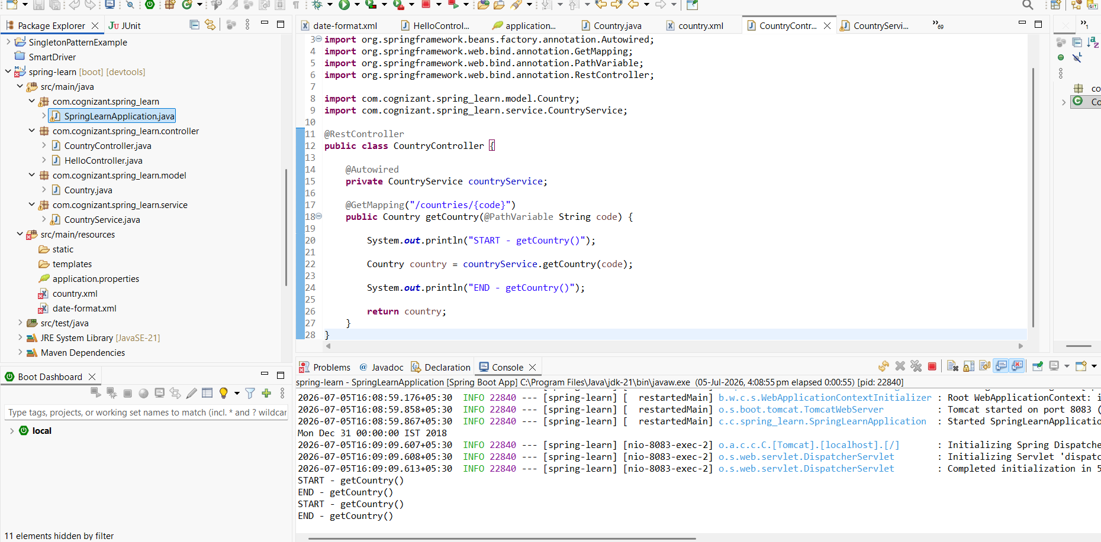
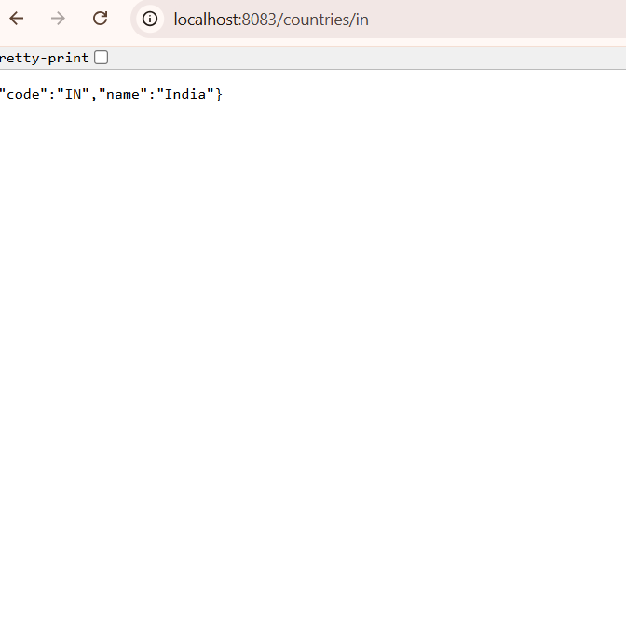

Create authentication service that returns JWT:
